**Report on Face-recognition**

**Face recognition in Python**

**Introduction-**

One of the simplest ways to tell someone's identity from from another is by looking at their face. A personal identification method called face recognition analyses a person's physical features to determine their identity. The process of recognising a human face essentially consists of two phases: face detection, which occurs in humans extremely quickly, and introduction, which recognises a face as an individual.

**Face recognition** is the task of determining if a face that has already been detected is a known or unknown face. Face detection is sometimes mistaken with face recognition, however face recognition is the process of determining whether the input face belongs to a **database of known or unknown faces.**

# **Face -Recognition — Step by Step**

1. **Finding all faces-**Using the HOG method, compress an image to get a more compact version.Then find the area of this compressed image that most closely resembles a face represented by a generic HOG encoding.
2. **Posing and Projecting Faces-**By identifying the key facial landmarks, determine the facial position. Use those markers to warp the image once we've located them so that the eyes and mouth are centered.
3. **Encoding Faces-** Run a neural network that understands how to measure facial traits through the centred face image. Keep track of all measurement.
4. **Finding the persons name from encoding-** Find the individual whose measurements are the most similar to our face's measurements among all the faces we have previously measured. That's our match!

## **Implementation of Python code**

1. In order to install Face-recognition library ,we need to first install dlib.

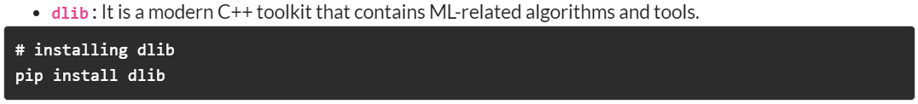

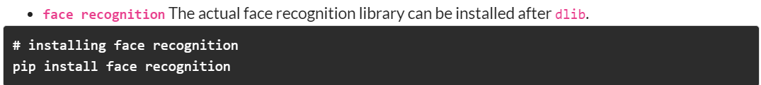

1. These are simply the imports. We will be using the built-in os library to read all the images in our corpus and we will use **face_recognition** for the purpose of writing the algorithm.



1. Save image received through POST request from the client and save it on some directory on server.

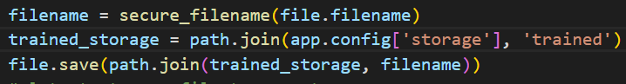

1. Save the user information and image path in sqlite database.





1. Recognizing our uploaded image by comparing input image with all saved images on servers file system.

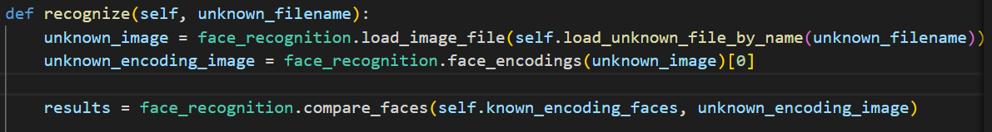

***Reason why we allocate AI in frontend and backend*** :-

* One of the most popular uses of AI is facial recognition. It is one of the most advance form of biometric authentication that can recognise and confirm a person by looking at facial features in a photo or video pulled from a database.Thats why we need to **train our model** and keep trained model **offline** then used its **instance for matching.**
* **Application** of Face-recognition App.-This technology can be used in various field which needs AI based model for their work to be done at ease.
* Insurance Underwriting: To compare a person's face to the one on their photo ID proof, several insurance companies use facial recognition technology. The underwriting process moves along much more quickly in this method.
* Security :This can be used for various projects, such as finding people or opening the door if a family member is detected.
* Facial recognition technology is one component of AI-driven surveillance systems that law enforcement can deploy.
* Many larger companies have utilised this technology, such as Google Photos, which uses similar faces to categorise photographs.